Memory leak analysis using Yourkit Profiler tool.

1. Analysis of “Memory” tab info

* Open “Memory” tab in profiler and look at the “Heap Memory” chart.
* Force GC and see is memory usage reduced
* If not all memory was reclaimed there is a memory leak
* Find which threads running at some point after GC was forced
* Create “Memory Snapshot”

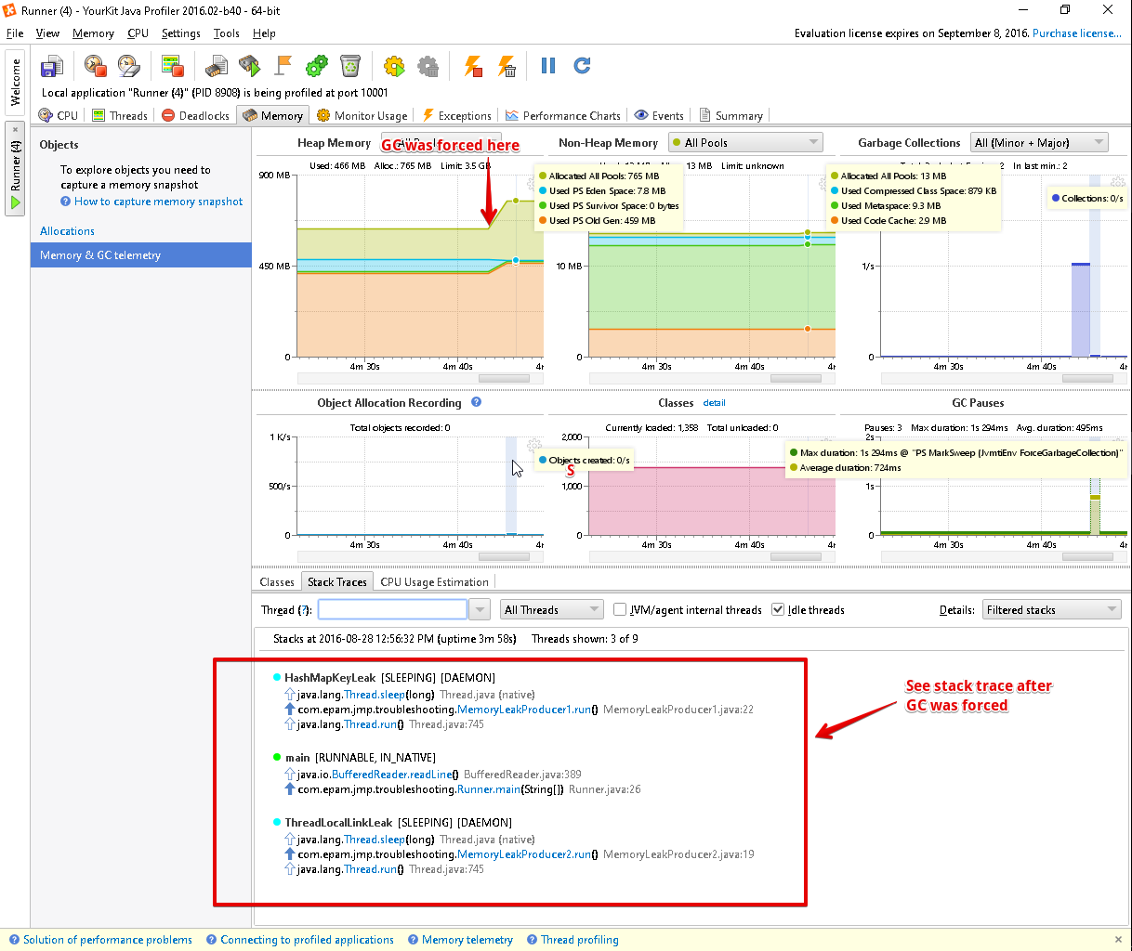

1. Analysis of Memory Snapshot

* Perform “Calculate exact retained sizes” to find classes which objects retain most memory and sort by “Retained size”
* Find classes from my application that retain most memory

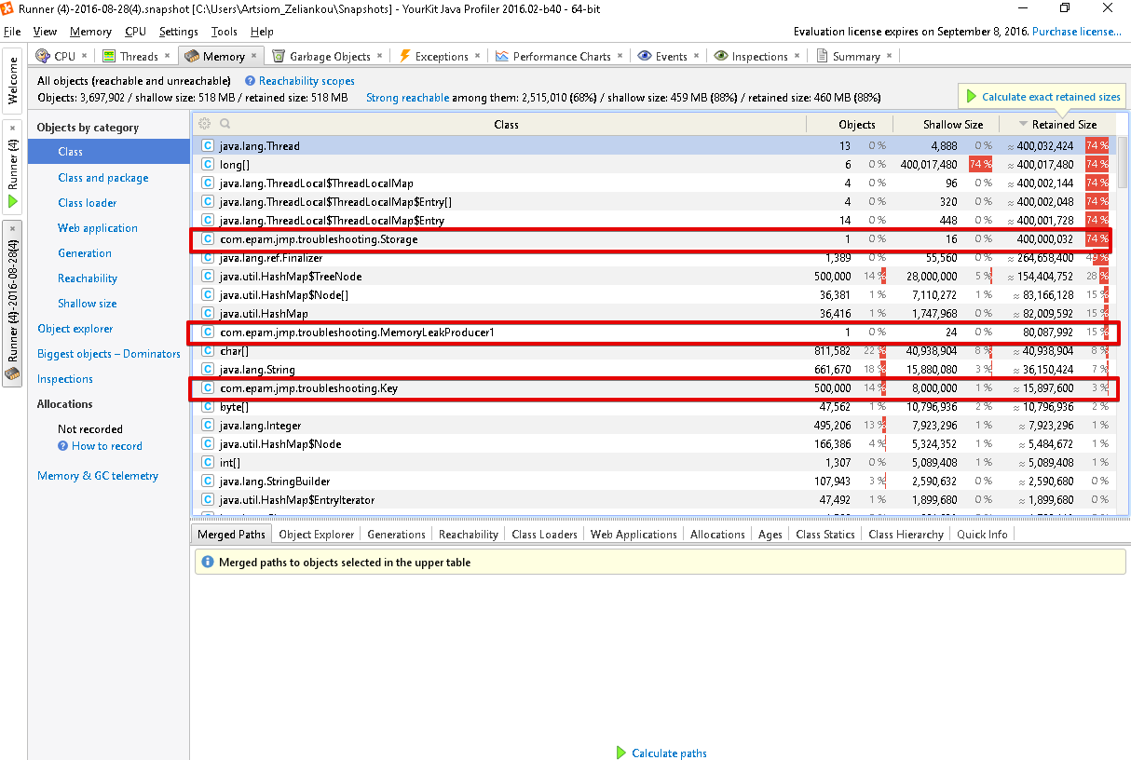

* Go to “Biggest Objects - Dominators” view to see individual objects that retain most of memory

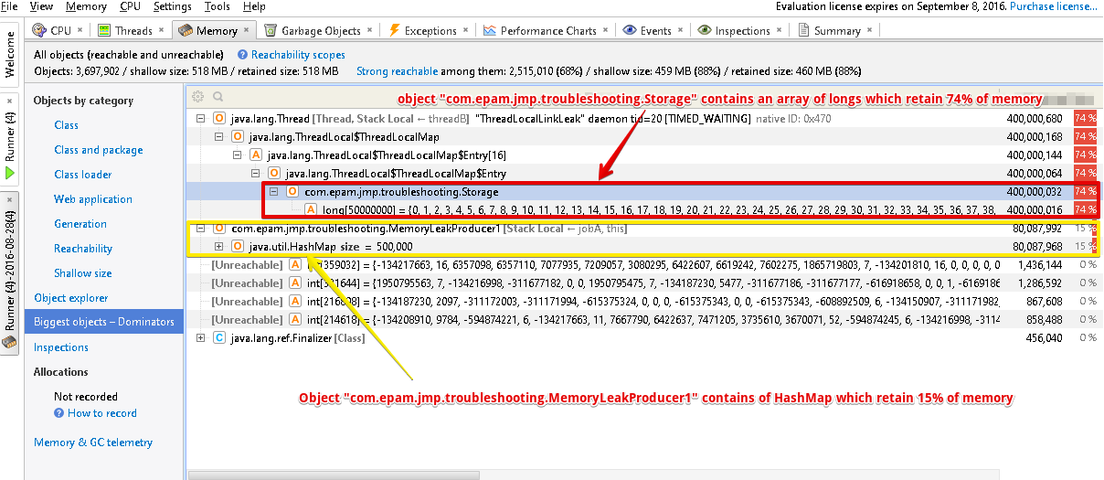

* For Each big object calculate path to see a chain of object references which retain the object from GC

